

**MANAGEMENT FOR ENGINEERS**

[**CEU44E01-202223**](https://tcd.blackboard.com/webapps/blackboard/execute/courseMain?course_id=_72181_1)

**CASE STUDY – PROJECT NIGHTINGALE**

Name: Mudit Garg

TCD ID: 21355125

E-Mail ID: gargmu@tcd.ie

Mobile: +353892050748

In submitting this work, I verify that this submission is my very own work and I accept all obligation for any copyright infringement which can arise as a result of this submission.

**QUESTION 1:** Develop a clear project objective that reflects the perspectives of each stakeholder group and present the Project Priority Matrix. Explain your reasoning. Do not state theory. Instead apply the theory to this case study. *(10%)*

The objective of the project is to produce 30 working models of Nightingale before or in time for MedCON which is going to be held on **16th October, 2023**. It is critical for the project to be planned and executed in a way that it gets aligned with the interests of every stakeholder.

Team Members: The primary goal for the whole team is to complete this project in time for MedCON because rumours are that competitors are considering developing a similar product and being first to the market will have a significant sales advantage.

Rassy Brown: Rassy Brown aims to use half of her discretionary fund of €200,000 to accelerate the project so that it concludes in time. She wants to hold onto at least €100,000 to deal with unexpected problems.

Medical Technicians and Paramedics: Nightingale’s success lies in the fact that it is developed according to the needs and requirements of these end users. It is also crucial that it is easy to use because its purpose is during the emergency scenarios.

The deadline is crucial to the success of the project. The budget can be a little flexible to accelerate the project in order for it to meet its deadline. Also, the scope of the project has been decided upon and is accepted.

Hence the **Project Priority Matrix** translates to something like this:

|  |  |  |  |
| --- | --- | --- | --- |
|  | CONSTRAIN | ENHANCE | ACCEPT |
| Scope  -OR-  QUALITY |  |  | ◆ |
| RESOURCES  -OR-  COST |  | ◆ |  |
| SCHEDULE  -OR-  TIME | ◆ |  |  |

**QUESTION 2:** Examine a few project management software packages (at least three) and evaluate them in terms of what you require in order to be able to carry out this assignment. Select the software you will use to produce a project schedule, Gantt charts, and network diagrams. Explain why you selected the software you eventually used. In a previous lecture, you were given the names of many packages which are available, together with instructions on how to download MS Project to a Windows machine. Please note that Boot Camp on a Mac can be used to enable you to run MS Project on the Mac. *(5%)*

There are many project management tools that help automate various tasks like task assignment, resource allocation and milestone tracking for all phases of a project. Quite a variety of these tools were given a thought to see if they fit our project needs.

* Trello: Built for the purpose that users spend more time getting things done and less time learning how to use this tool, Trello is a very easy to use project management tool, mainly known for its simplicity. The only caveat Trello faced was that it lacked certain essential features significant to the project like the option to product Gantt Charts, Network models, etc.
* Gantt Pro: Gantt Pro is a robust project management tool with its superpower in handling Gantt charts. Also having many features like task management, progress tracking, resource and time management, Gantt Pro felt like an intuitive package with a short learning curve. But Gantt Pro was available but with a cost. It also lacking in key areas like integration with other platforms like Google Drive, etc.
* Microsoft Project Professional, 2019: MS Project by Microsoft provides a seamless project management experience with many features crucial to our project like the option to produce a Gantt Chart, adding Start-to-Finish or Start-to-Start relation between activities with the inclusion of lag, etc. MS Project felt like a comprehensive project management tool with great documentation and customisation options and easy to use interface due to its similarity with daily used tools like MS Word, Excel, PowerPoint, etc.

**QUESTION 3:** Using your chosen project management software, develop the initial programme/schedule for the project using the normal times. For this schedule:

• Present the Gantt chart showing the critical path(s) and the estimated completion date.

• List the tasks on the critical path(s).

• Present the network diagram, showing the earliest and latest start and finish times, and the total slack of each activity.

Develop one or two further schedules in which you explore the different options you could adopt in order to be able to complete the project in line with the specified constraints, the deadline, and the Project Priority Matrix. Explain your reasoning for each one. For each of these options, present the Gantt chart showing the critical path(s) and the estimated project completion date. List the tasks on the critical path(s) and present the additional cost of each option. The Gantt charts should clearly indicate what task or tasks has/have been crashed. Identify the final schedule you would recommend is adopted and explain your reasoning. *(55%)*

**Initial Approach**:

Using the initial parameters (such as planned activities, network information, time estimates, company holidays, 8 hours working days, no overtime) set by the project team, a WBS (Working Breakdown Structure) was created which resulted in the following initial output of the project timeline and details:

Estimated completion date: **8th December, 2023 (Fri 8-12-23)**

Tasks on Critical Path (*marking by red on the Gantt chart (or) free slack = 0*):

* Architectural designs
* Internal specifications
* External specifications
* Database
* Review design
* Integration
* Procure Prototype components
* Assemble prototypes
* Field Test Prototypes
* Lab Test Prototypes
* Adjust design
* Order stock parts
* Assemble first production unit
* Test Unit
* Produce 30 units
* Train Sales Representative

By analysing the below attached Gantt chart and Network model, it can be observed that the initial approach is not feasible. This is due to the fact that time is a crucial constraint (by the Project Priority Matrix) as it affects the success (sales) of the project and hence indirectly affects the stakeholders. This initial approach leads to the project being late by almost 2 months (53 days to be precise). Creation of a new approach was inevitable for eventual success of Project Nightingale.

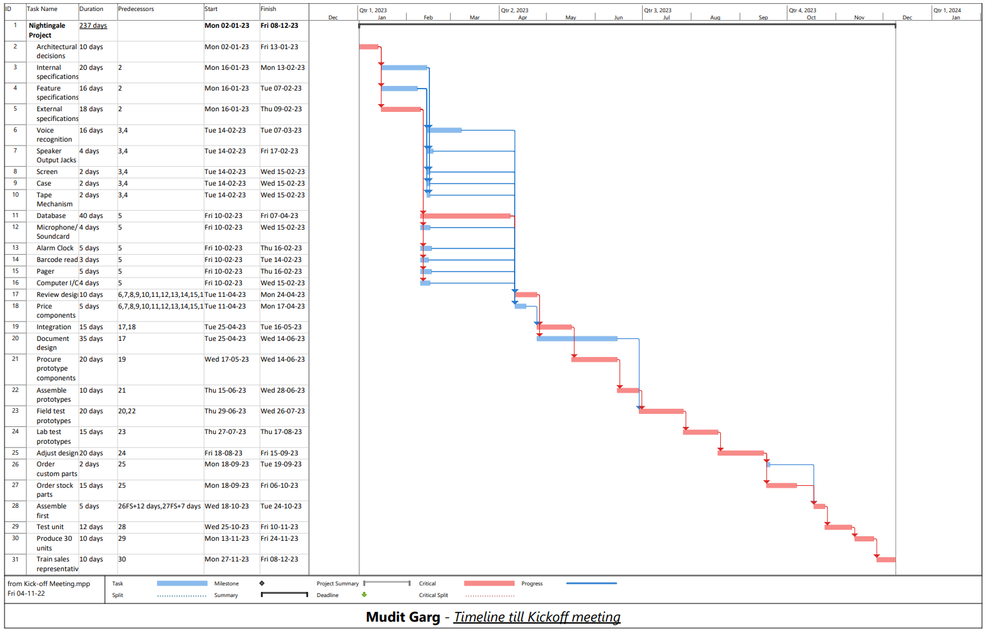

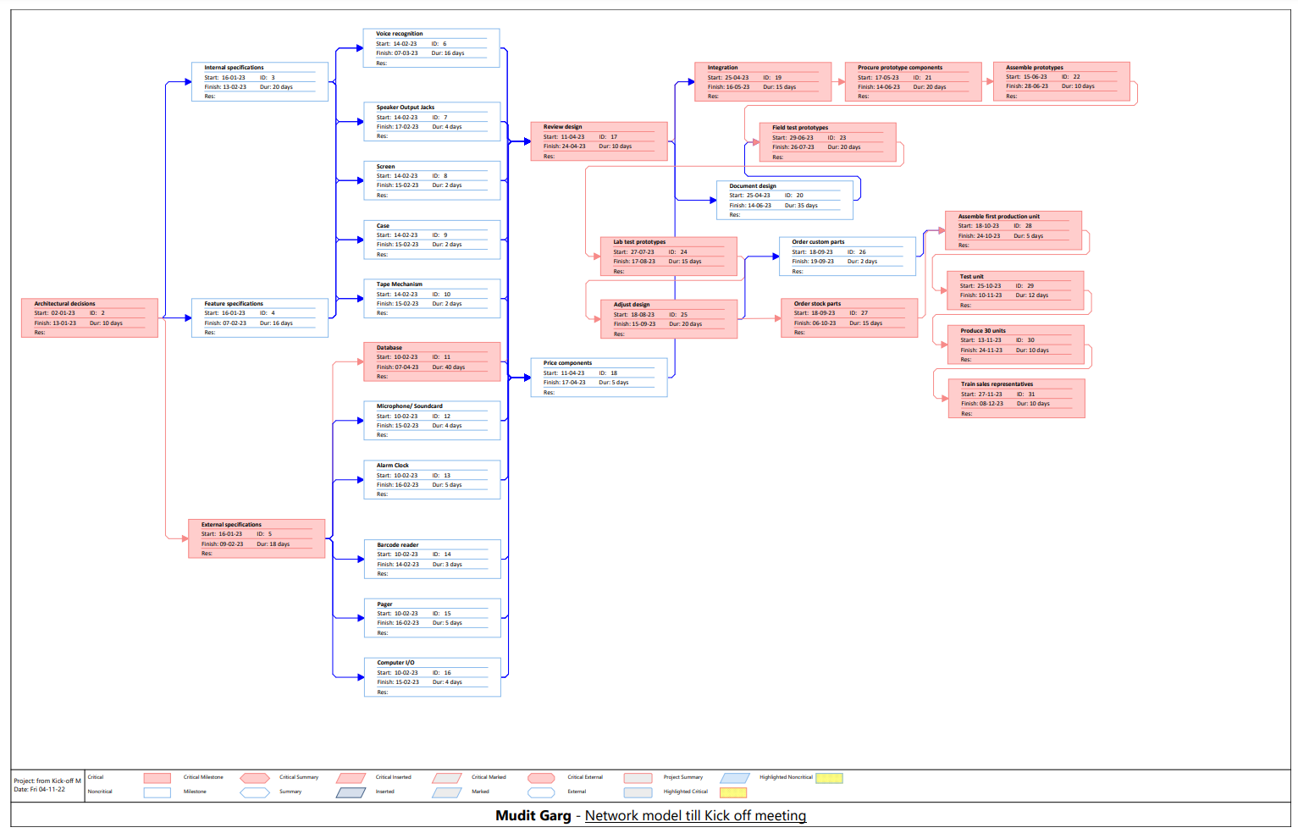

**Improved Approach – Ken’s suggestions**:

Using the initial approach did not yield a desirable result. Ken Clark’s suggestion to introduce Start-to-Start relationships instead of Finish-to-Start relationships between various activities without changing any other parameters, helped to reduce unnecessary time gaps between activities. This further accelerated the project. This resulted in the following project timeline and model:

Estimated completion date: **3rd November, 2023 (Fri 3-11-23)**

Additional Costs: **€0 (lags do not incur any additional costs)**

Tasks on Critical Path (*marking by red on the Gantt chart (or) free slack = 0*):

* Architectural designs
* Internal specifications
* External specifications
* Database
* Review design
* Integration
* Procure Prototype components
* Assemble prototypes
* Field Test Prototypes
* Lab Test Prototypes
* Adjust design
* Order stock parts
* Assemble first production unit
* Test Unit
* Produce 30 units
* Train Sales Representative

Ken’s suggestions (*IDs used in the Gantt chart are mentioned beside)*:

|  |  |  |
| --- | --- | --- |
| Task Title | Previous Predecessor | Suggested Predecessor |
| **Document design (20)** | Review Design (17)  Finish-to-Start | 17 Start-to-Start + 5 days |
| **Adjust design (25)** | Lab Test Prototypes (24) Finish-to-Start | 24 Start-to-Start + 10 days |
| **Order stock parts (27)** | Adjust Design (25)  Finish-to-Start | 25 Start-to-Start + 5 days |
| **Order custom parts (26)** | Adjust Design (25)  Finish-to-Start | 25 Start-to-Start + 5 days |
| **Training sales representatives (31)** | Produce 30 units (30) Finish-to-Start | (Test Unit) 29 Start-to-Start + 5 days, 30 Finish-to-Finish + 5 days |

By analysing the below attached Gantt chart and Network model, it can be observed that implementing the Start-to-Start relationships between various tasks help to reduce redundant time gaps between activities by enabling parallel run of activities which do not depend upon each other. This is quite effective as it accelerates the project by almost a month (35 days to be precise) without the involvement of any additional funds. But this is not enough as the project 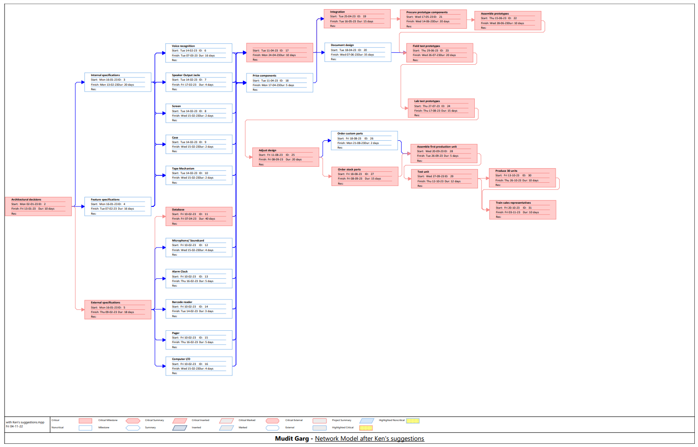would 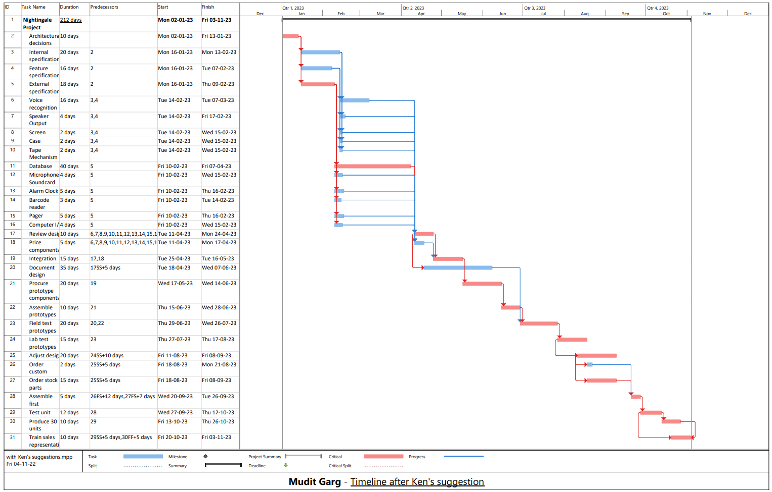still be almost half a month (18 days to be precise) behind. And time is a constraint here.

**Final Optimal Approach – Using Ken’s suggestion and Additional Funds**:

Although the improved approach from Ken’s suggestions did accelerate the project, but it did not help tackle the critical deadline for MedCON. The only option left without sacrificing any features (accepted Scope should not be changed according to the decided Project Priority Matrix) was to dip into additional funds to decrease time taken by certain activities (Resources were subject to enhancement according to the decided Project Priority Matrix). This resulted in the following project timeline and model:

Estimated completion date: **11th October, 2023 (Wed 11-10-23)**

Tasks on Critical Path (*marking by red on the Gantt chart (or) free slack = 0*):

* Architectural designs
* Internal specifications
* External specifications
* Database
* Review design
* Integration
* Procure Prototype components
* Assemble prototypes
* Field Test Prototypes
* Lab Test Prototypes
* Adjust design
* Order stock parts
* Assemble first production unit
* Test Unit
* Produce 30 units
* Train Sales Representative

Additional Costs: **€80,000**

Summary of crashed activities:

|  |  |  |  |
| --- | --- | --- | --- |
| Activity | Initial Duration | Final Duration | Additional Cost |
| External Specifications | 18 days | 10 days | €30,000 |
| Procure Prototype Components | 20 days | 15 days | €40,000 |
| Order Stock Parts | 15 days | 12 days | €10,000 |

From the given budget of €100,000, **a total of €80,000 was used to crash a few activities** that helped to further accelerate the project. Among the given options to crash activities, the choice of critical tasks (that affected other tasks) was taken (except *Creation of Database*) so that the advantage of reduced duration could also be taken by other activities. This helped the team conclude Project Nightingale 5 days before time for MedCON. This would hence provide some marginal additional time for polishing and error reduction activities.

**Note:** Among those critical tasks, the *Creation of Database* was not chosen due to its high additional cost. Although choosing it would result in the project completion date to reach 5th October, 2023, but cost reduction is also an aspect of Project Management that needs to be under strict surveillance. Those additional funds saved due to not choosing this can be used to 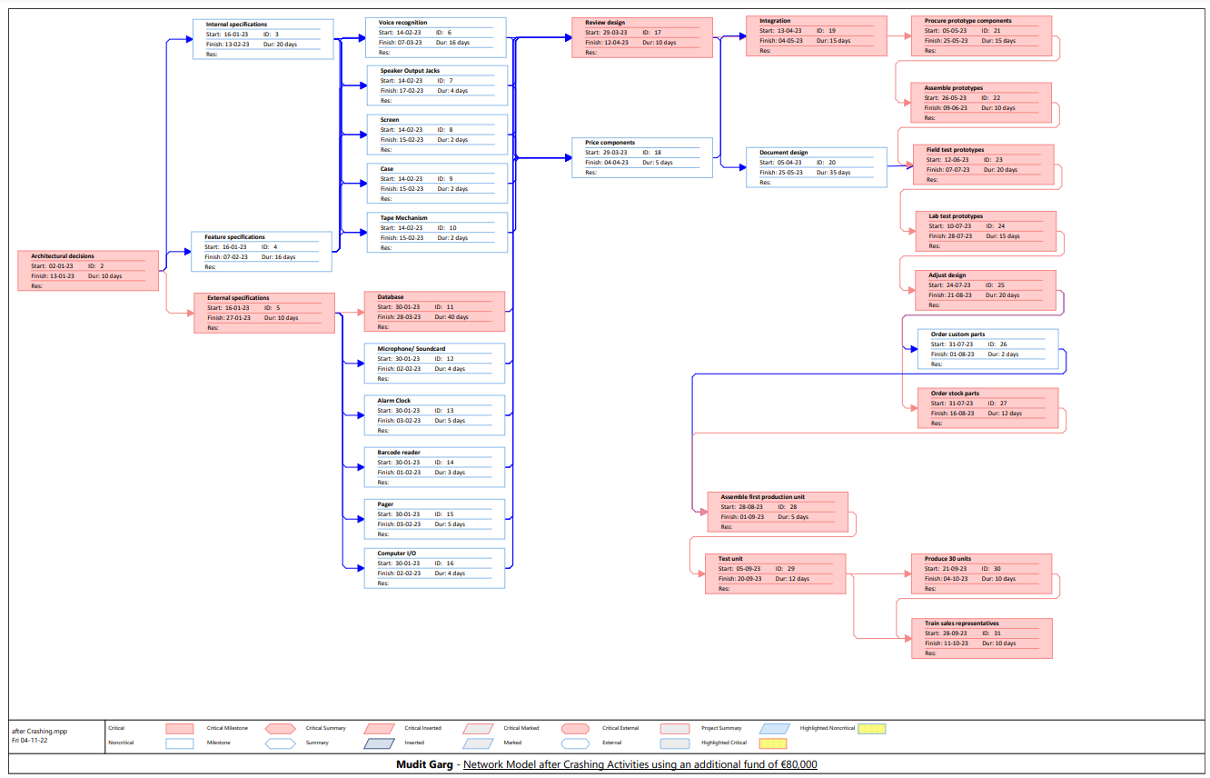deal 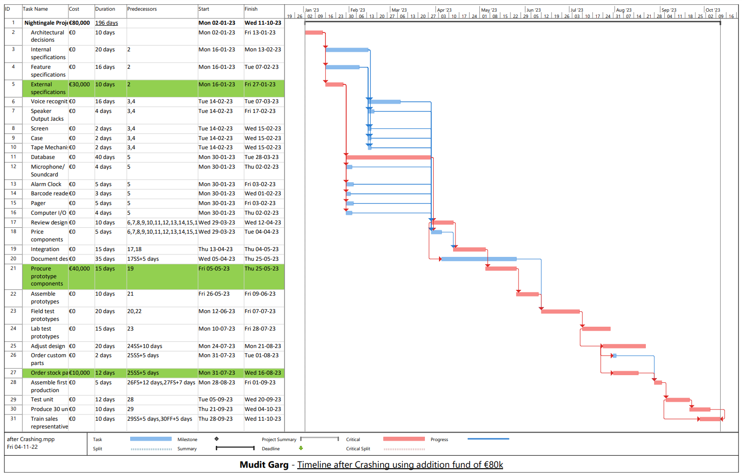with unexpected problems (€20,000 to be precise).

**QUESTION 4:** Produce a risk register for the project using the three steps described in the lectures. Explain your reasoning. Do not state theory. Instead apply the theory to this case study.  *(15%)*

In an ideal scenario, the project could be completed within the deadline using Ken’s suggestions and using additional funds to crash certain tasks on the critical path(s). But in a realistic scenario, there are numerous potential risks that could hamper the progress and timeline of the project.

**Risk Identification:**

It would help if all the potential risks are brainstormed beforehand, to mitigate their effects on the project progress. By analysing every nook and cranny of the project, some of the potential risks are:

* Team Risks - Team disparity, Personnel incompetence, Sudden staff shortage
* Product Risks - Bugs during testing, Quality compromise
* Legal Risks - Litigations or False accusations from other competitors
* Financial Risks - More than planned expenditure (shortage of funds)

**Risk Assessment:**

The below table quantifies the likelihood of the risks mentioned above, the impact they could have on the project and timeline and how difficult would it be to detect those risks before they become catastrophic enough to disrupt the whole project. All those three factors add up to form the Risk Value of a particular risk. (Risk Value = Likelihood x Impact x Detection Difficulty)

*Likelihood*:1 = unlikely, …., 5 = very likely; *Impact*: 1 = not serious, …., 5 = catastrophic

*Detection Difficulty*: 1 = plenty of time to react, …., 5 = no warning

|  |  |  |  |  |
| --- | --- | --- | --- | --- |
| EVENT | LIKELYHOOD  (0 – 5) | IMPACT  (0 – 5) | DETECTION DIFFICULTY  (0 – 5) | RISK VALUE  (0 - 125) |
| Team Disparity | 4 | 4 | 2 | 32 |
| Personnel Incompetence | 3 | 4 | 4 | 48 |
| Sudden Staff Shortage | 2 | 5 | 5 | 50 |
| Bugs during testing | 4 | 4 | 4 | 64 |
| Quality compromise | 3 | 3 | 3 | 27 |
| Accusations from other competitors | 3 | 4 | 5 | 60 |
| Shortage of funds | 3 | 4 | 2 | 24 |

**Risk Response Development:**

After assessing possible risks and their impacts on the project, the next step is to find ways to respond if such a risk is ever encountered in the time period of a project. The two elements in risk response development are *Risk Response*, if such a risk is actually encountered and *Contingency Plans*.

|  |  |  |
| --- | --- | --- |
| EVENT | RESPONSE | CONTINGENCY PLAN |
| Team Disparity | Set up meetings to figure out the problem and enable better communication between team members | Hold regular meetings so that there is clear communication between team members and chances of differences are minimum |
| Personnel Incompetence | Replace less skilled members with members with more competence or train them before letting them onto the project | Always check personnel competence and train them well beforehand |
| Sudden Staff Shortage | Replace old personnel by hiring new employees and release vacancies into the market with same skill set requirements | Train new employees and keep them posted about the project so that when needed, they can work with max efficiency |
| Bugs during testing | Roll out updates regularly with bug fixes | Create variety of test cases to weed out the bugs from the final product |
| Quality compromise | Increase the skills of the members by training them better and use better quality resources | Regular quality checks on the product and resources should be conducted and standards of quality must be set beforehand |
| Accusations from other competitors | Deal with such accusations calmly and prevent further spend of resources on the conflict and rather use them on improving the product | Prepare for all sorts of moves expected from competitors and be updated on various actions and advancements of the competition |
| Shortage of funds | Better manage funding and prevent wastage of funds | Always keep some portions of funds aside to deal with future shortages |

These three steps, *Risk Identification, Risk Assessment* and *Risk Response Development,* altogether form the Risk Register which is a very effective way of handling risks way before they pose a threat to the project as a whole, in Project Management.

**QUESTION 5:** What are the team dynamics and team building approaches that Rassy Brown should consider and how should he deal with these? List the things to consider, assess if they will impact on the project, and suggest actions if necessary. Explain your reasoning. Do not state theory. Instead apply the theory to this case study. *(15%)*

Getting a talented highly skilled team for a project is not enough. Developing a high-performance dynamic between the team members is also an essential part of team building and is very crucial to the success of the project. Some of the team building approaches that Rassy Brown could follow to ensure a superior performance by his team are:

* **Know your team:** Rassy should build a connection with the team members using team building exercises. This can greatly *help predict and pre-emptively solve future problems effectively* before they could pose a threat to the project objectives. Moreover, building a connection with others will make *coordinating project work easier* for Rassy. This could also *reduce the “black sheep” effect* in which one finds it difficult to interact with others they consider different.
* **Define responsibilities:** Projects that lack guidance and defined roles usually derail from their direction or goal. This results in the development of poor team dynamics and increased damage to the project deadlines. Rassy should define roles and responsibilities of each and every member during the initial phase of the project. This will *help every member focus their energy on their particular assigned tasks* rather than giving their partial divided attention to the whole project.
* **Communication is the key:** Clear regular communication is the centre to great team dynamic. Rassy should include all sorts of communication mediums like emails, meetings, shared documents, announcements, etc. to *keep the whole team posted about the project progress* and *remove any sort of ambiguity*. This way, the team has the same information to work with.
* **Watch the whole team carefully:** Even after everything, there can be instances where the team can develop some sort of problems resulting in the degradation of team dynamics. Rassy should always keep an eye on the whole team and always be on a look out for any sort of differences developing. *Reinforcing positive behaviour can help team members bond and work together to achieve their goal of completing the project together.*